**Computer Hardware**

**Computer hardware** (usually simply called **hardware** when a computing context is concerned) is the collection of physical elements that constitutes a computer system. Computer hardware is the physical parts or components of a computer, such as the monitor, mouse, keyboard, computer data storage, hard disk drive (HDD), graphic cards, sound cards, memory, motherboard, and so on, all of which are physical objects that are tangible.  In contrast, software is instructions that can be stored and run by hardware.

Software is any set of machine-readable instructions that directs a computer's processor to perform specific operations. A combination of hardware and software forms a usable computing system

Von Neumann architecture

[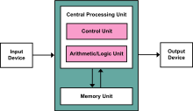](https://en.wikipedia.org/wiki/File:Von_Neumann_Architecture.svg)

The template for all modern computers is the Von Neumann architecture, detailed in a [1945 paper](https://en.wikipedia.org/wiki/First_Draft_of_a_Report_on_the_EDVAC) by Hungarian mathematician John von Neumann. This describes a design architecture for an electronic digital computer with subdivisions of a processing unit consisting of an [arithmetic logic unit](https://en.wikipedia.org/wiki/Arithmetic_logic_unit) and [processor registers](https://en.wikipedia.org/wiki/Processor_register), a [control unit](https://en.wikipedia.org/wiki/Control_unit) containing an [instruction register](https://en.wikipedia.org/wiki/Instruction_register) and [program counter](https://en.wikipedia.org/wiki/Program_counter), a [memory](https://en.wikipedia.org/wiki/Computer_memory) to store both data and [instructions](https://en.wikipedia.org/wiki/Instruction_(computer_science)), external [mass storage](https://en.wikipedia.org/wiki/Mass_storage), and [input and output](https://en.wikipedia.org/wiki/Input_and_output) mechanisms.  The meaning of the term has evolved to mean a [stored-program computer](https://en.wikipedia.org/wiki/Stored-program_computer) in which an instruction fetch and a data operation cannot occur at the same time because they share a common [bus](https://en.wikipedia.org/wiki/Bus_(computing)). This is referred to as the [Von Neumann bottleneck](https://en.wikipedia.org/wiki/Von_Neumann_bottleneck) and often limits the performance of the system.

### Personal computer

Basic hardware components of a modern personal computer, including a monitor, a motherboard, a CPU, a RAM, two expansion cards, a power supply, an optical disc drive, a hard disk drive, a keyboard and a mouse.

Inside a custom-built computer: power supply at the bottom has its own cooling fan.

The personal computer, also known as the PC, is one of the most common types of computer due to its versatility and relatively low price. Laptops are generally very similar, although may use lower-power or reduced size components.

#### Case

The computer case is a plastic or metal enclosure that houses most of the components. Those found on desktop computers are usually small enough to fit under a desk, however in recent years more compact designs have become more common place, such as the all-in-one style designs from Apple, namely the iMac. Though a case can basically be big or small, what matters more is which form factor of motherboard it’s designed for. Laptops are computers that usually come in a clamshell form factor, again however in more recent years deviations from this form factor have started to emerge such as laptops that have a detachable screen that become tablet computers in their own right.

#### Power supply

A power supply unit (PSU) converts alternating current (AC) electric power to low-voltage DC power for the internal components of the computer. Laptops are capable of running from a built-in battery, normally for a period of hours.

#### Mainboard

The motherboard is the main component of a computer. It is a large rectangular board with integrated circuitry that connects the other parts of the computer including the CPU, the RAM, the disk drives(CD, DVD, hard disk, or any others) as well as any peripherals connected via the ports or the expansion slots.

Components directly attached to or part of the motherboard include:

* The **CPU** (Central Processing Unit) performs most of the calculations which enable a computer to function, and is sometimes referred to as the "brain" of the computer. It is usually [cooled](https://en.wikipedia.org/wiki/CPU_cooling) by a heat sink and fan. Most newer CPUs include an on-die Graphics Processing Unit (GPU).
* The **Chipset**, which includes the north bridge, mediates communication between the CPU and the other components of the system, including main memory.
* The **Random-Access Memory**.(RAM) stores the code and data that are being actively accessed by the CPU.
* The **Read-Only Memory** (ROM) stores the [BIOS](https://en.wikipedia.org/wiki/BIOS) that runs when the computer is powered on or otherwise begins execution, a process known as [Bootstrapping](https://en.wikipedia.org/wiki/Bootstrapping_(computing)), or "[booting](https://en.wikipedia.org/wiki/Booting)" or "booting up". The [**BIOS**](https://en.wikipedia.org/wiki/BIOS) (Basic Input Output System) includes boot [firmware](https://en.wikipedia.org/wiki/Firmware) and power management firmware. Newer motherboards use [Unified Extensible Firmware Interface](https://en.wikipedia.org/wiki/Unified_Extensible_Firmware_Interface) (UEFI) instead of BIOS.
* **Buses** connect the CPU to various internal components and to expand cards for graphics and sound.
* The **CMOS battery** is also attached to the motherboard. This battery is the same as a watch battery or a battery for a remote to a car's central locking system. Most batteries are [CR2032](https://en.wikipedia.org/wiki/CR2032), which powers the memory for date and time in the BIOS chip.

#### Expansion cards

An expansion card in computing is a printed circuit board that can be inserted into an expansion slot of a computer motherboard or backplane to add functionality to a computer system via the expansion bus. Expansions cards can be used to obtain or expand on features not offered by the motherboard.

#### Storage devices

Computer data storage, often called storage or memory, refers to computer components and recording media that retain digital data. Data storage is a core function and fundamental component of computers. The price of solid-state drives (SSD), which store data on flash memory, has dropped a lot in recent years, making them a better choice than ever to add to a computer to make booting up and accessing files faster.

**Fixed media**

Data is stored by a computer using a variety of media. Hard disk drives are found in virtually all older computers, due to their high capacity and low cost, but solid-state drives are faster and more power efficient, although currently more expensive than hard drives, so are often found in more expensive computers. Some systems may use a disk array controller for greater performance or reliability.

**Removable media**

To transfer data between computers, a USB flash drive or Optical disc may be used. Their usefulness depends on being readable by other systems; the majority of machines have an optical disk drive, and virtually all have a USB port.

#### Input and output peripherals

Input and output devices are typically housed externally to the main computer chassis. The following are either standard or very common to many computer systems.

**Input**

Input devices allow the user to enter information into the system, or control its operation. Most personal computers have a mouse and keyboard, but laptop systems typically use a touchpad instead of a mouse. Other input devices include webcams, microphones, joysticks, and image scanners.

**Output device**

Output devices display information in a human readable form. Such devices could include printers, speakers, monitors or a Braille embosser.

### Mainframe computer

[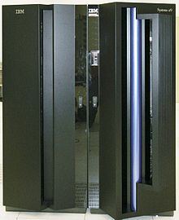](https://en.wikipedia.org/wiki/File:Front_Z9_2094.jpg)

Figure 1 An IBM System Z9 Mainframe

A mainframe computer is a much larger computer that typically fills a room and may cost many hundreds or thousands of times as much as a personal computer. They are designed to perform large numbers of calculations for governments and large enterprises.

### Departmental computing (aka minicomputers)

In the 1960s and 1970s more and more departments started to use cheaper and dedicated systems for specific purposes like process control and laboratory automation.

### http://amturing.acm.org/images/pdp-11-ritchie.jpg

### Supercomputer

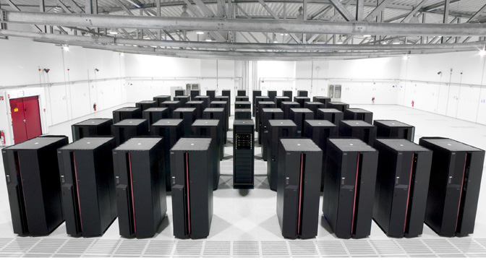

Figure 2 Tianhe-2 Supercomputer

A supercomputer is superficially similar to a mainframe, but is instead intended for extremely demanding computational tasks. As of November 2013, the fastest supercomputer in the world is the Tianhe-2, in Guangzhou, China.[[9]](https://en.wikipedia.org/wiki/Computer_hardware#cite_note-9)

The term supercomputer does not refer to a specific technology. Rather it indicates the fastest computers available at any given time. In mid 2011, the fastest supercomputers boasted speeds exceeding one petaflop, or 1000 trillion floating point operations per second. Super computers are fast but extremely costly so they are generally used by large organizations to execute computationally demanding tasks involving large data sets. Super computers typically run military and scientific applications. Although they cost millions of dollars, they are also being used for commercial applications where huge amounts of data must be analyzed. For example, large banks employ supercomputers to calculate the risks and returns of various investment strategies, and healthcare organizations use them to analyze giant databases of patient data to determine optimal treatments for various diseases and problems incurring to the country.

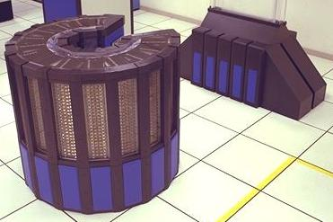

Figure 3 Cray-2 Supercomputer